Activity 22.1

1. A screenshot of a computer

   Description automatically generated with medium confidence
2. 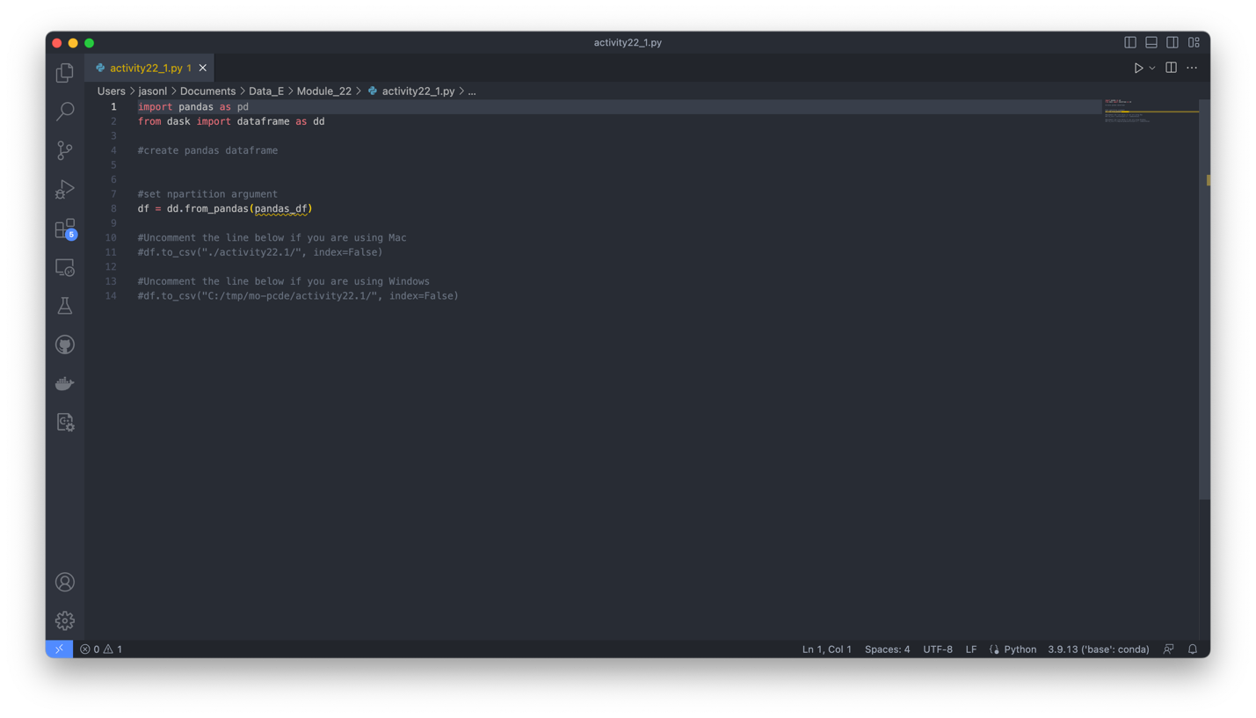
3. A screenshot of a computer

   Description automatically generated
4. A screenshot of a computer

   Description automatically generated
5. A screenshot of a computer

   Description automatically generated
6. A screenshot of a computer

   Description automatically generated
7. A screenshot of a computer

   Description automatically generated
8. A screenshot of a computer

   Description automatically generated